Переклад з української мови на англійську мову
Translation from Ukrainian into English

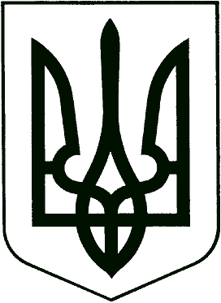

UKRAINE

BACHELOR’S
DEGREE DIPLOMA

B No. 102145
Derzhznak. Ukraine Printing Company. Order 0-3199, 2006, I quarter

CK No. 29271148 | DIPLOMA  Shcherbakova  Larysa Oleksandrivna  graduated in 2006 from Odesa State Academy of Refrigeration and obtained basic higher education majoring in “Computer Sciences” and is qualified as Bachelor.  Rector /signature/ V. V. Prytula  June 30, 2006  Official Seal:  Ministry of Education and Science of Ukraine* 02071085* Odesa State Academy of Refrigeration*

